**LAB 03 TASKS**

**Question # 1: Write a program to take two float numbers then find remainder of them by using type casting in integer form.**

**Source Code: Output:**

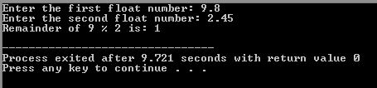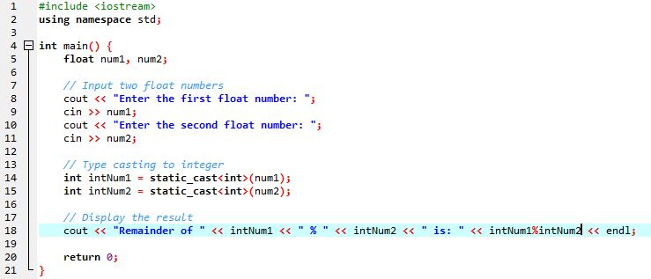

**Question # 2: Write a program to take input name, address and age from user, then display data on screen.**

**Source Code: Output:**

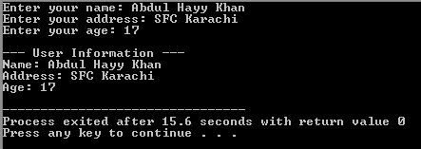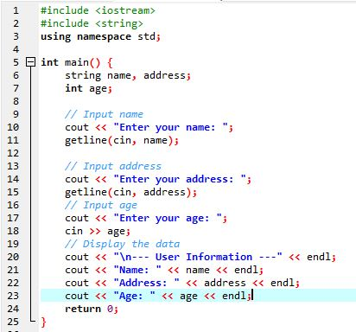

**Question # 3: Write a program to take input a character and display its ASCII code.**

**Source Code: Output:**

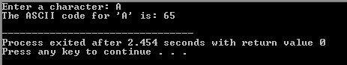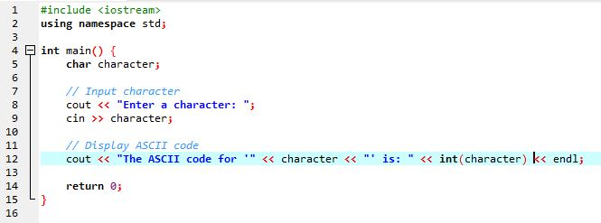

**Question # 4: Take an amount from user, interest rate and number of years from user let suppose 1000, 5% and 3. Find Interest amount for those years. (e.g. output for above values is 150)**

**Source Code: Output:**

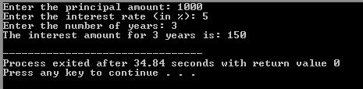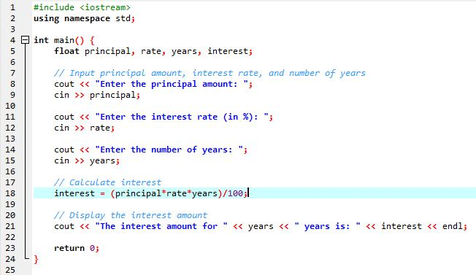

**Question # 5: Write a program to take dividend and divisor. Then display the quotient and remainder.(e.g. 20 3. Quotient=6, Remainder=2**

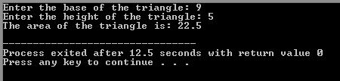**Source Code: Output:**

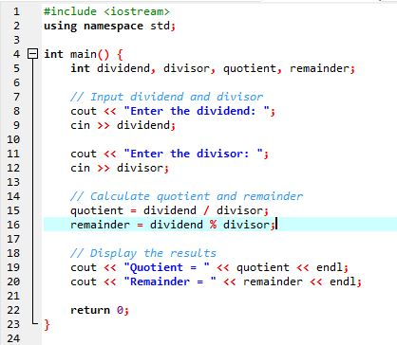

**Question # 6: Write a program to take input base and height of triangle. Now calculate area by using formula Area=1/2 x base x height.**

**Source Code: Output:**

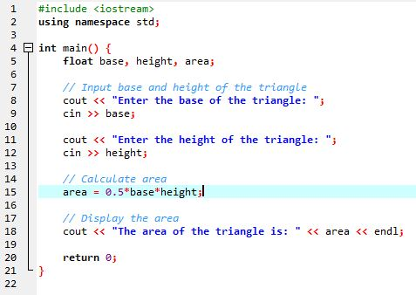

**Question # 7: Write a program to take temperature in Celsius and convert it into Fahrenheit by using F=9/5 *C +32.**

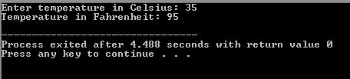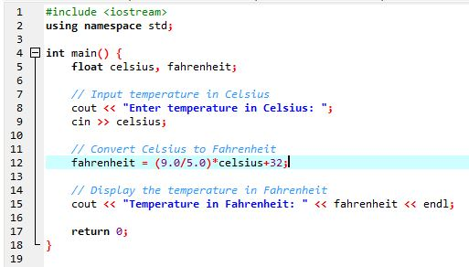**Source Code: Output:**

**Question # 8: Write a program to take three digit numbers from user then display its reverse order.**

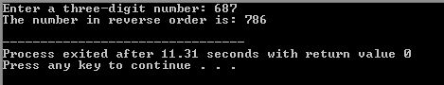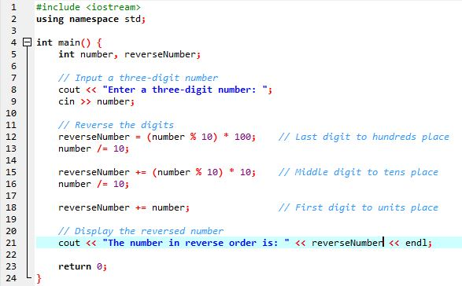**Source Code: Output:**